# **Setting up OpenVPN Access Server in AWS**

**Purpose:**

Purpose of the document is to standardise the installation process of OpenVPN on AWS.

**Intended Audience:**

This is for all the client-facing Engineers and freshers who they can follow the steps in the document and install + configure the OpenVPN on AWS.

**Objective:**

OpenVPN Access Server Provides an enterprise VPN solution for businesses of all sizes, providing a securely encrypted connection to private networks over unsecured public internet. With this single solution, you can protect business data communications and provide encrypted remote access to on-premises, hybrid, and public cloud resources.

**Execution steps:**

# **STEP 1 — Launch OpenVPN Access Server from AWS Marketplace**

1. Sign into the AWS Management Console and navigate to the **EC2 service**
2. If you are in India change your region to nearby location (eg: Mumbai)Then click on Launch Instance.

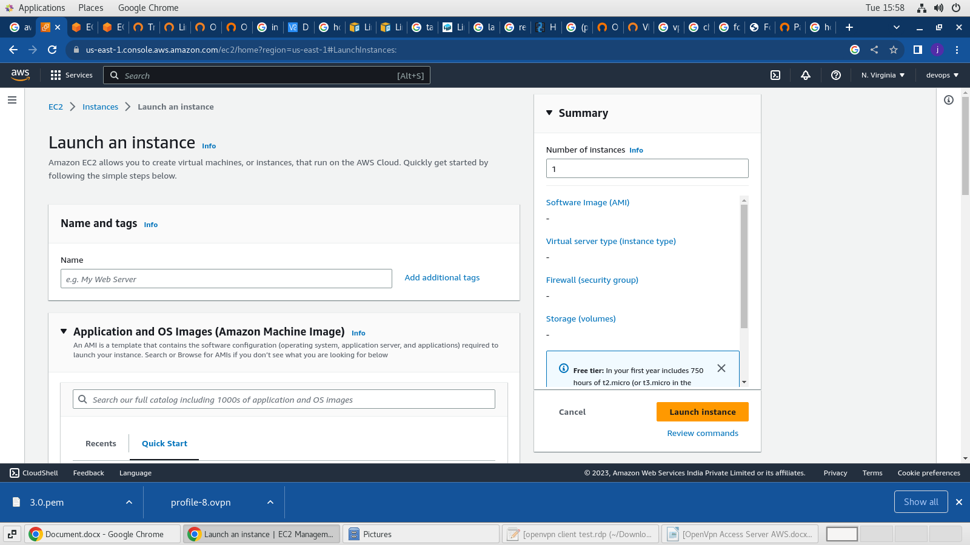

1. In the dashboard, click AWS Marketplace menu and type OpenVPN Access Server

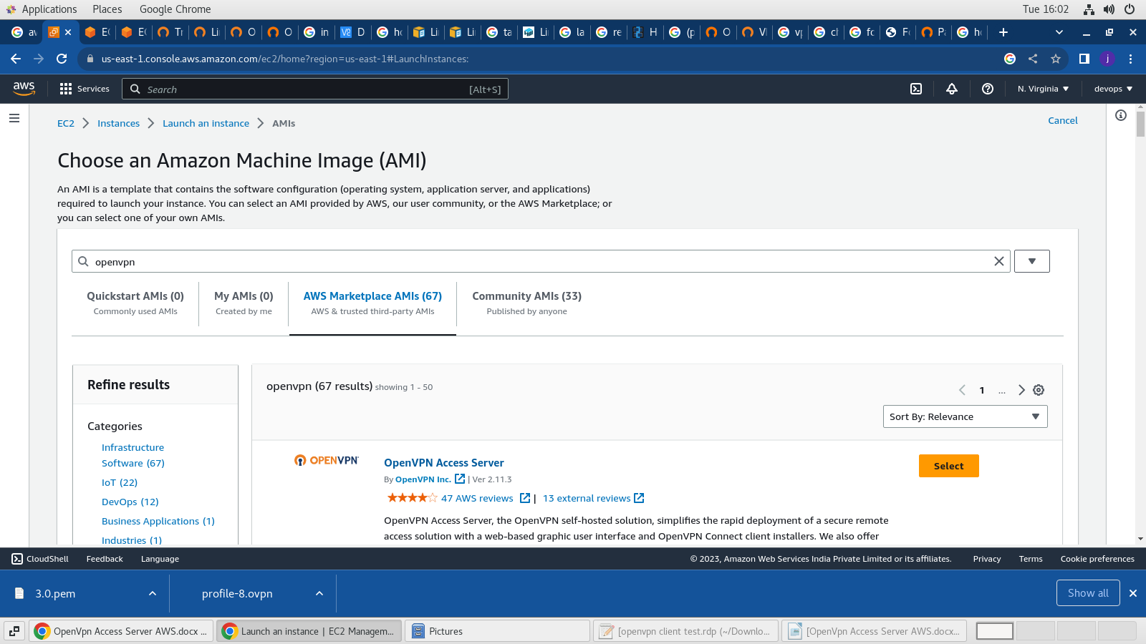

1. On the next page click Continue and Select t2.micro from the instance type list and click on Review and Launch button.
2. Create a new key pair (or use an existing one if you already have one), enter a name, and click download key pair. Then click Launch Instance and wait for the instance to go to running state.

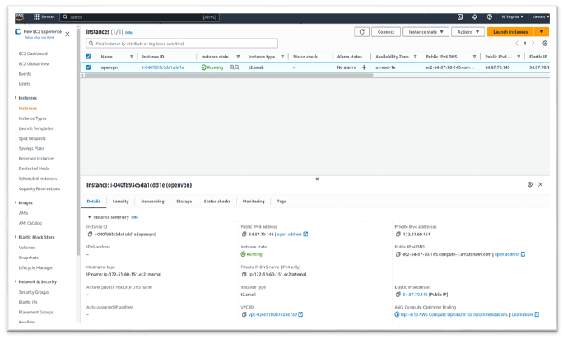

# **STEP 2 — Configure the Server**

1. If you’re using a Linux or Mac machine, open your terminal and SSH to your server as openvpnas: **“ssh -i "{keyname}.pem" openvpnas@{Your-IPv4-Public-IP}”**
2. Next, type **yes** for the agreement, then you’ll be prompted with how you want to configure your VPN.

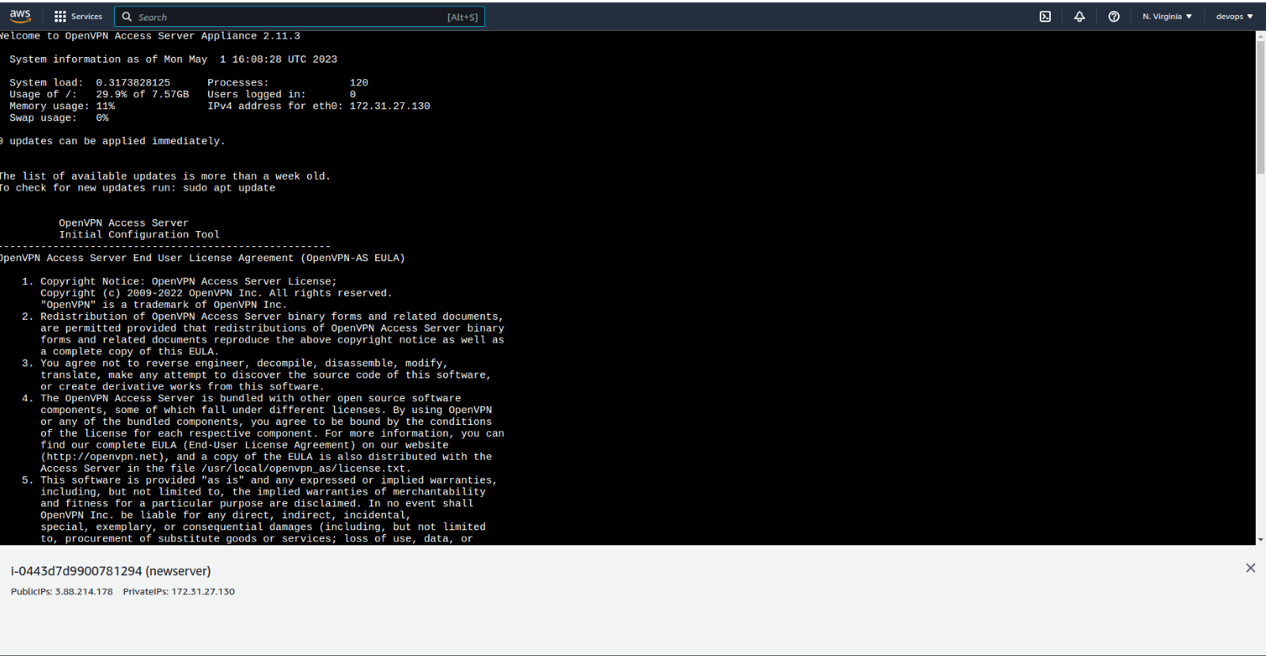

1. Just hit enter for the rest to have all the defaults confirmed.

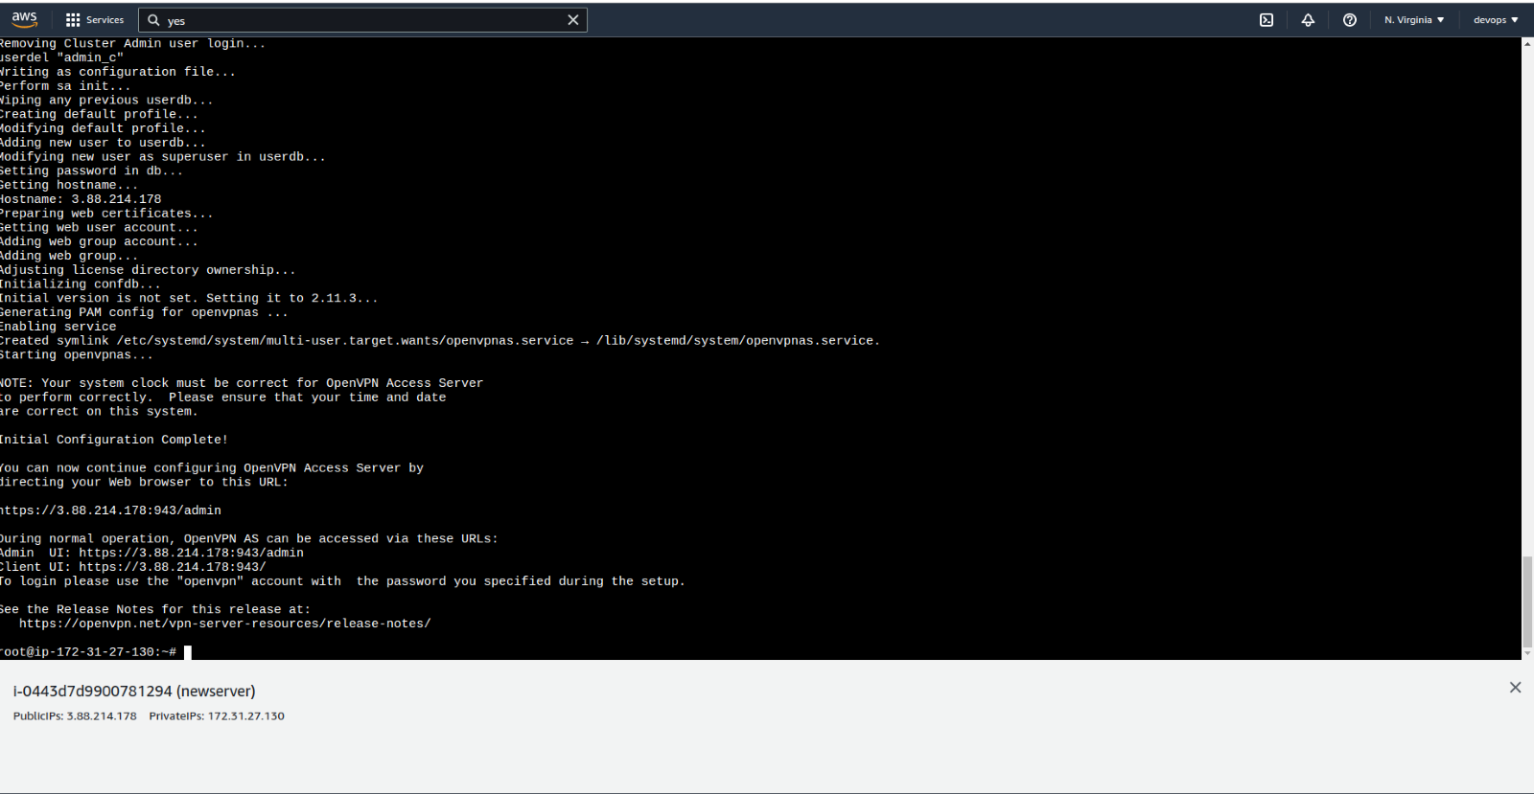

1. Once you reach the end, change the password for the user. Enter a new password twice and you’re all set.
2. Command to change password: sudo passwd openvpnas
3. Next, open a browser window and type: https://{Your-IPv4-Public-IP-address}:943/admin

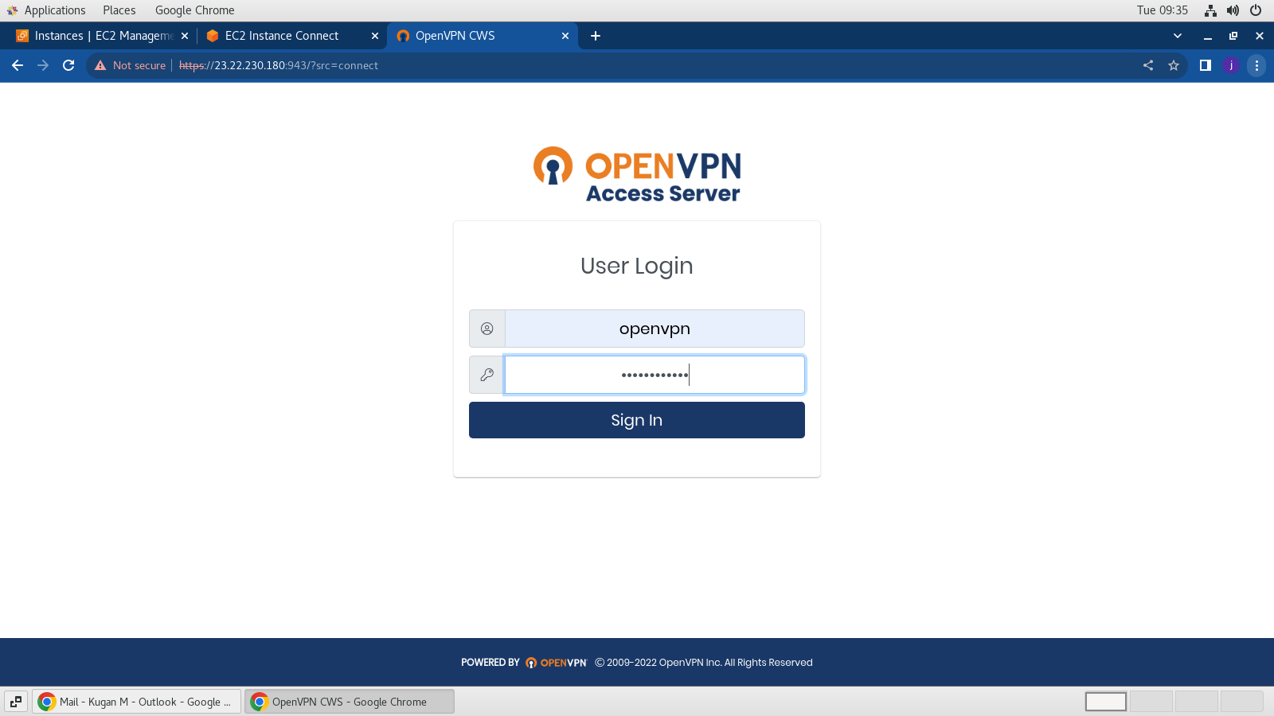

1. Login with openvpn and the password you just set and agree the terms and conditions to get into the OpenVPN access server dashboard.

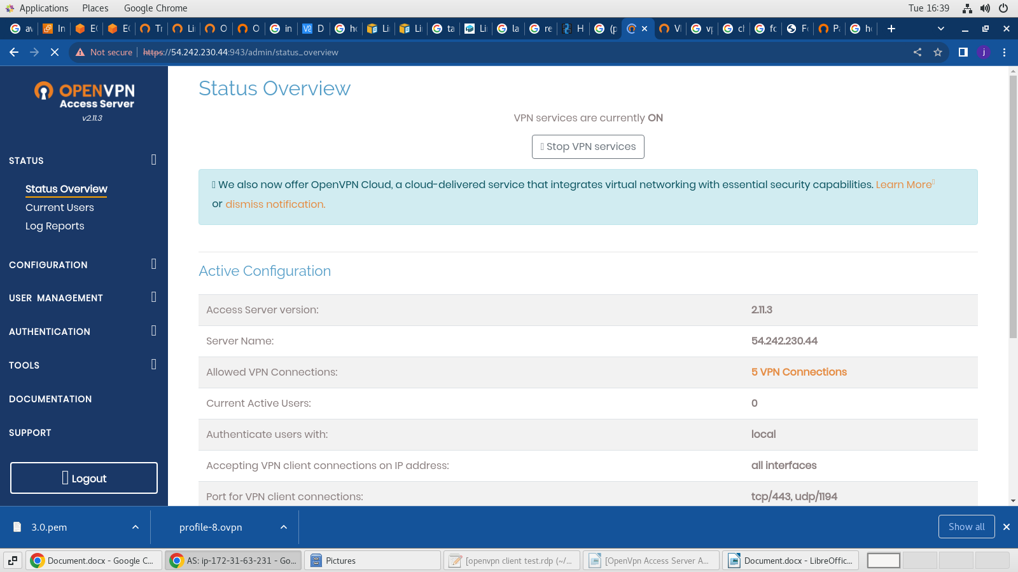

**STEP 3 — Using the VPN**

A VPN Client is required that can handle capturing the traffic you wish to send through the OpenVPN tunnel, encrypting it, and passing it to the OpenVPN server.

1. Open a browser and enter the below client URL to download the OpenVpn Client

Client URL: [https://public-ip-of-server:943/](https://private-ip-of-server:943/)

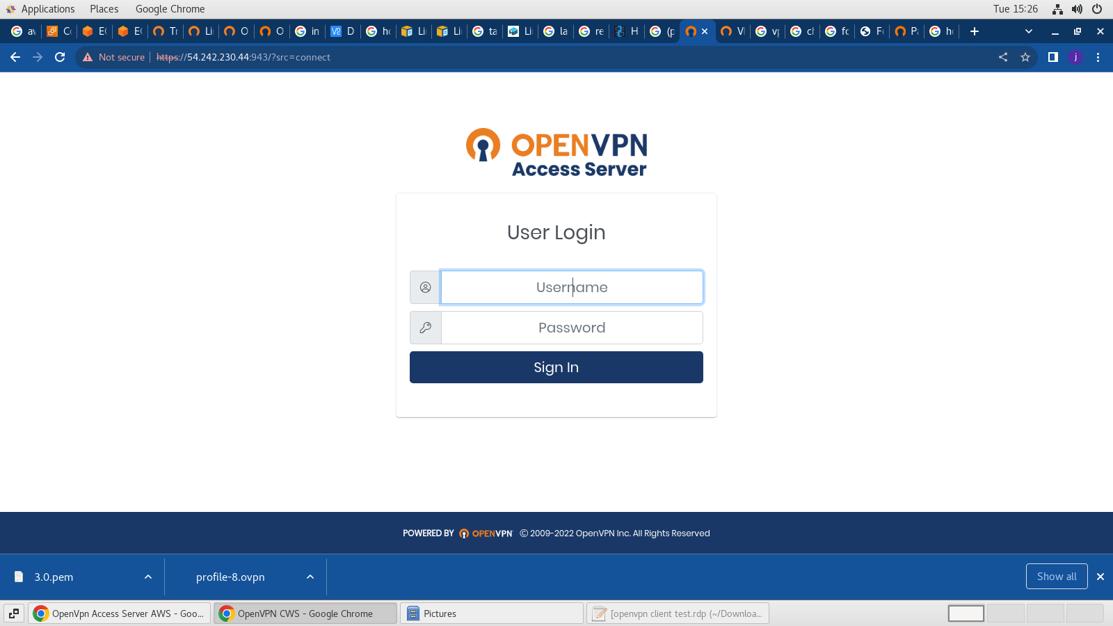

2. Once logged in download the OpenVPN Client according to the OS flavor

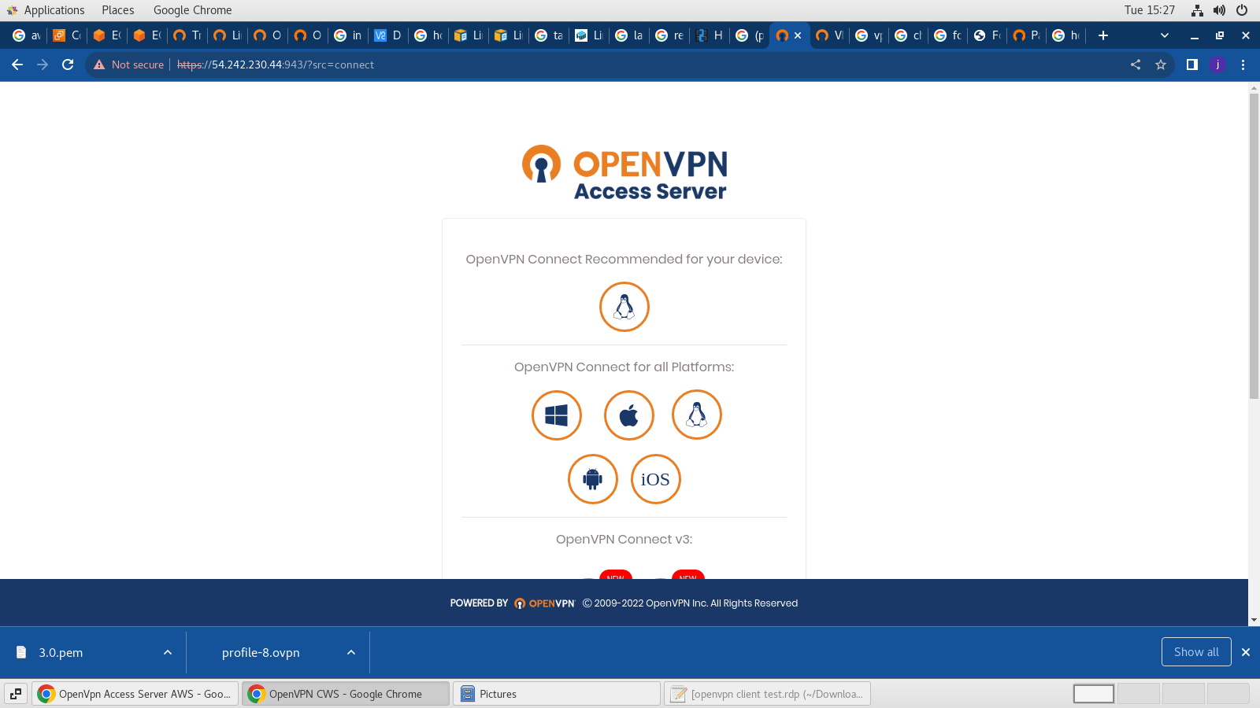

3. Open the OpenVPN client and enter the public URL followed by Username and password to get the VPN client connected to the VPN server in AWS

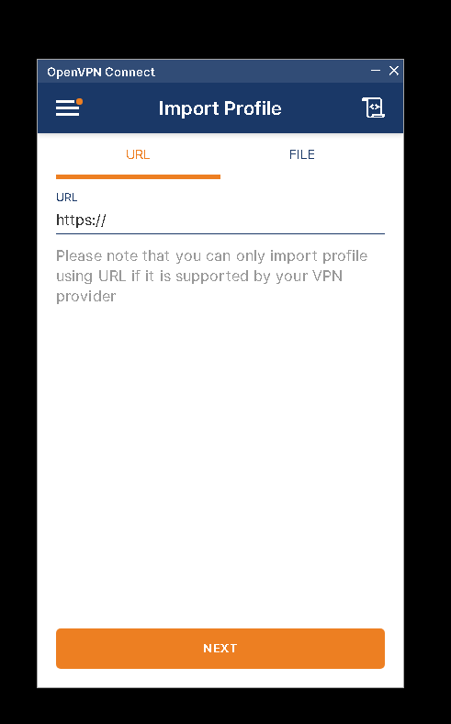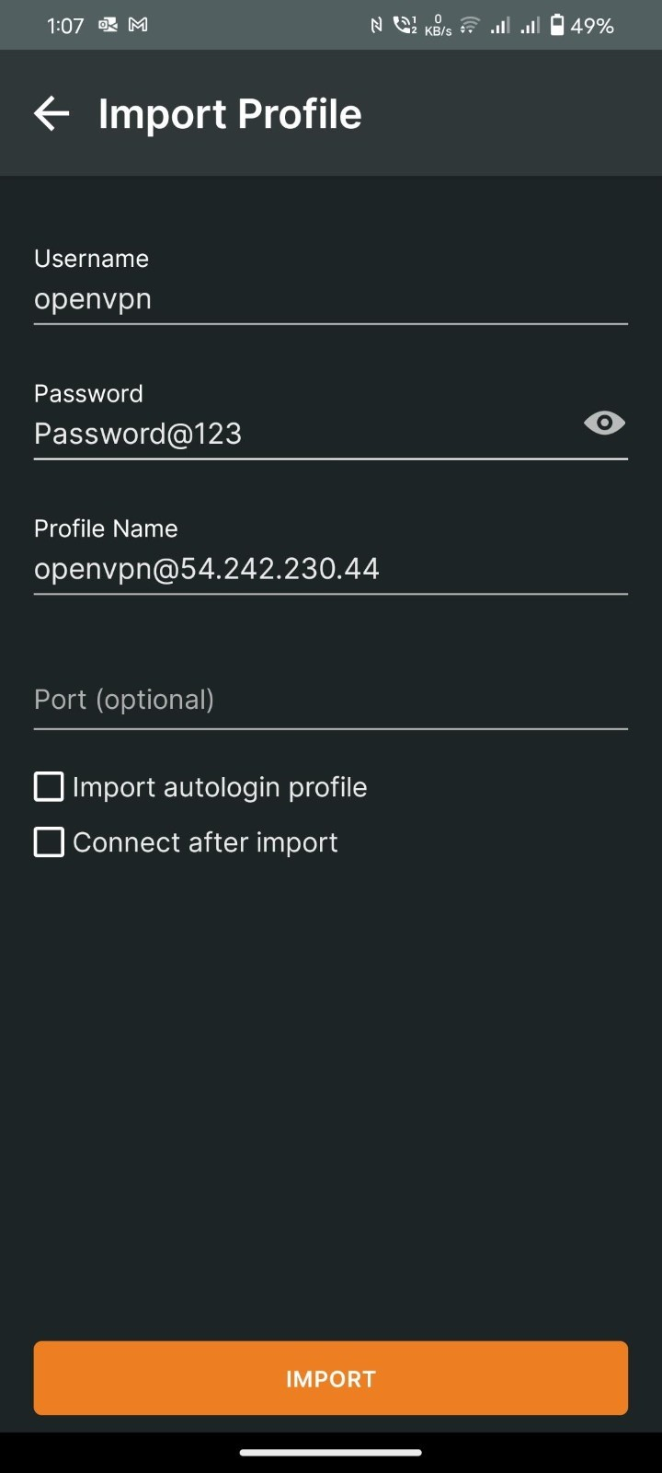

4. Post entering the required details import the profile and click on connect

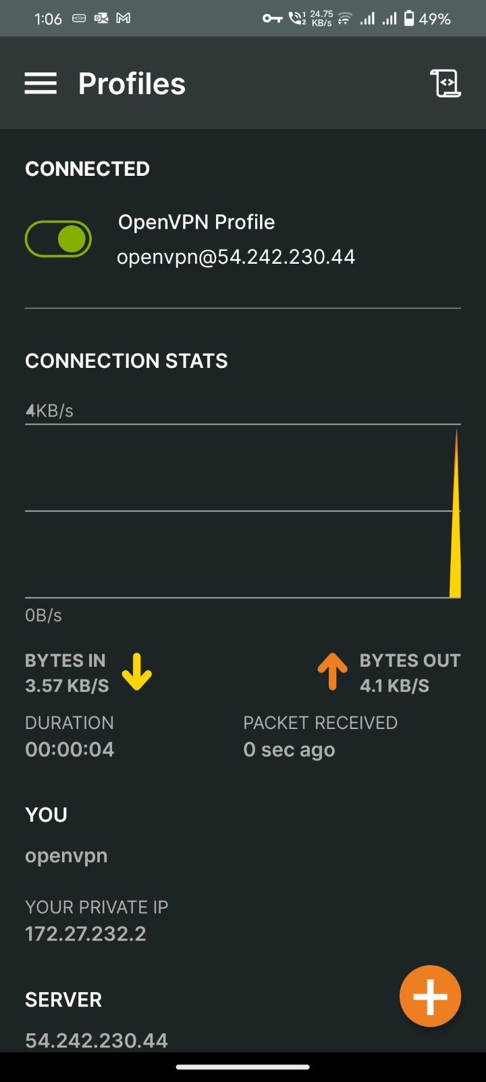

5. OpenVPN is connected